# READ ME!

**by telecommunication engineering and management**

## STEP1: How to run the car?

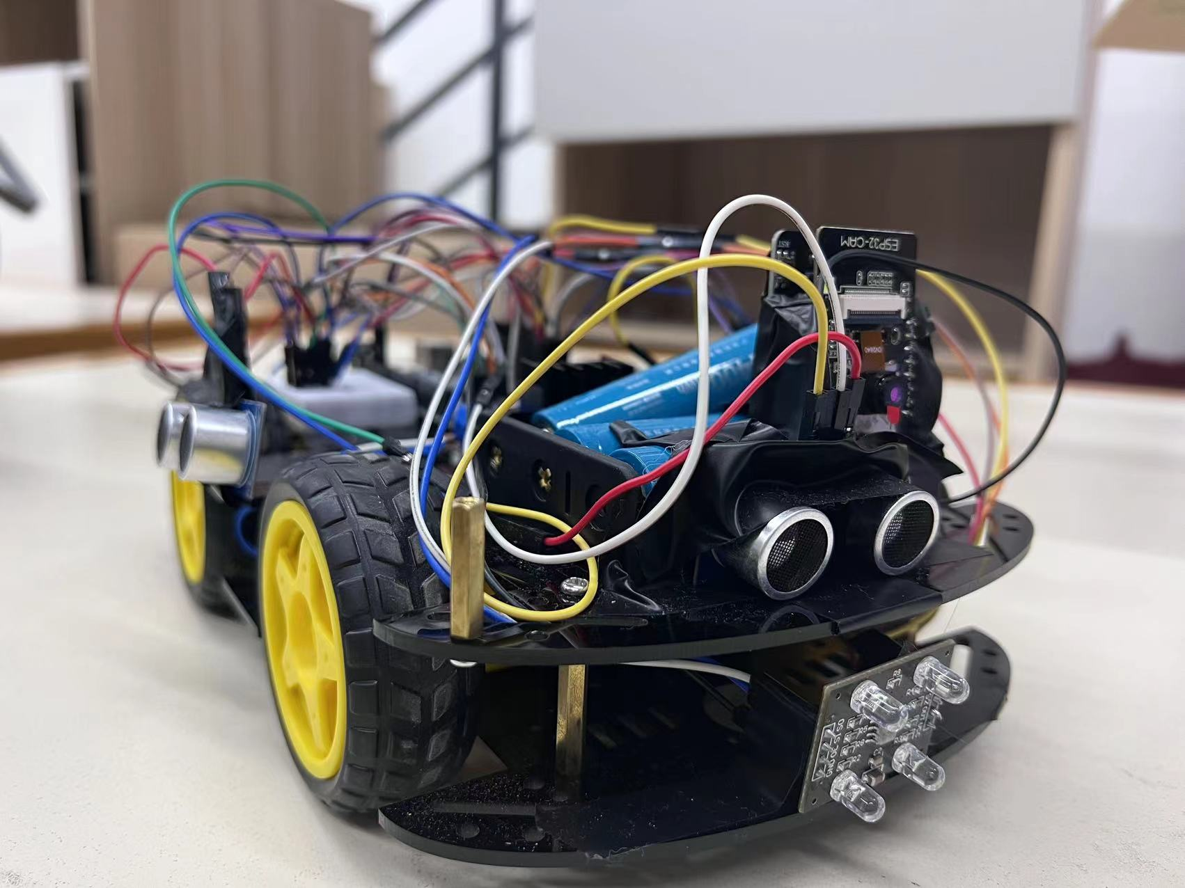

There are two batteries in the front and back of the car.

You must open both of the batteries, then the car will begin to move.

## STEP2:How to pass the maze?

You can put the car on the entrance of the maze. After turning on the switch, the car will enter the maze, find the treasures and return to the maze automatically. We aslo have a colour color. If it find something that are red, yellow or blue, it will stop for 5 seconds and turn back to go to the entrance of the maze.

## STEP3:How to use the camera?

If you want to connect to the camera, you must make sure that your laptop/phone has connected to a wifi and its name is Design24 and password 13788940648（You can create this wifi by a phone hotspot.）.Then you can access the interface of the camera by enter the website (<http://192.168.102.246/>).